**OUTPUT LISTING ……..**

FRONT PAGE :- 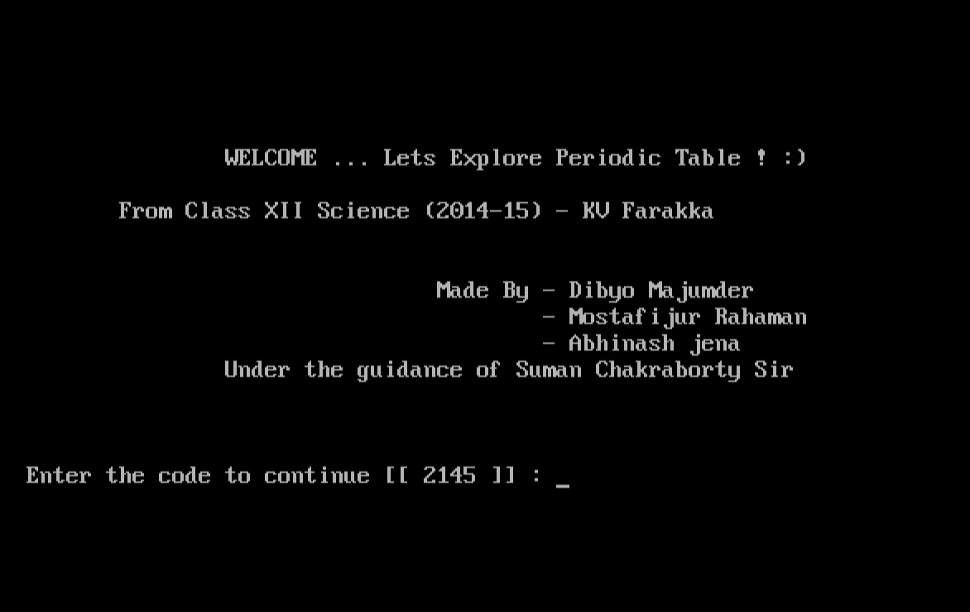

DISPLAY PERIODIC TABLE !! (MODULE 1 )

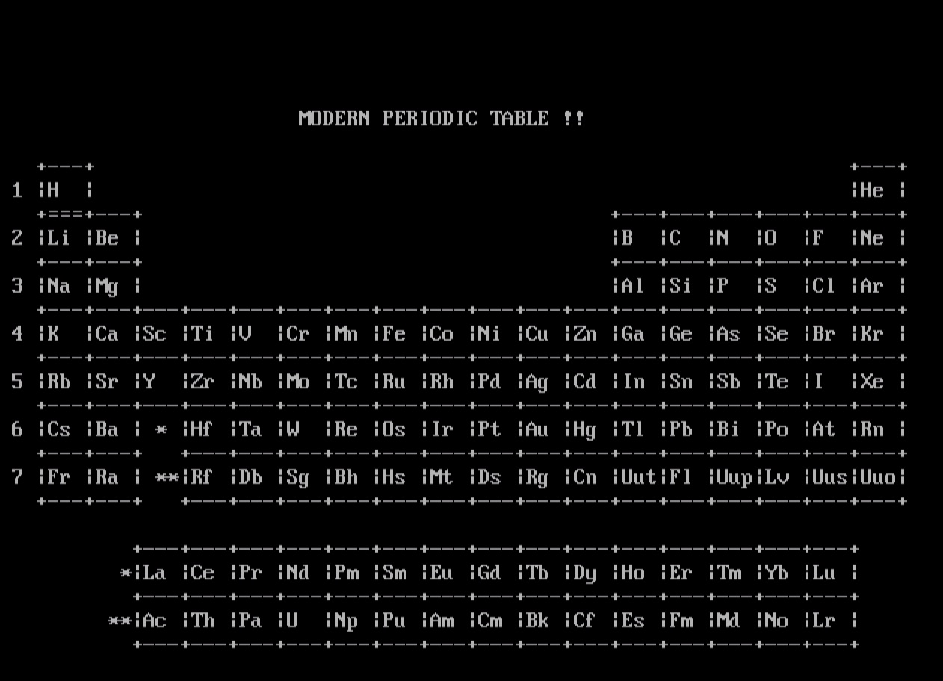

SHOW PROPERTIES .. !! (MODULE 2)

